Accounts
User Role: Admin - juliustolentino.diamond@gmail.com
User Role: Registrar - hbaki386@gmail.com
User Role: Dean - juliustolentino0101@gmail.com
User Role: Faculty - juliusexample@gmail.com
User Role: Student - crowsnight379@gmail.com

Log-in - Suggestion

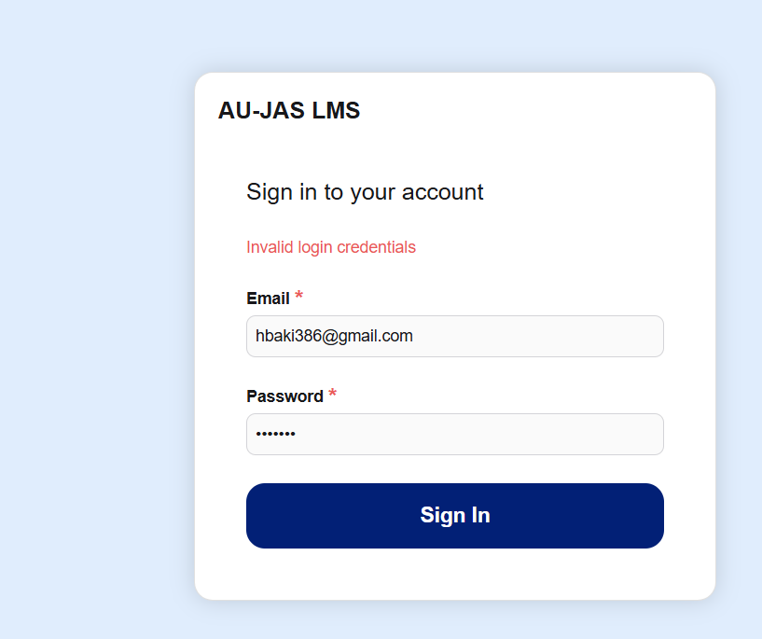
Suggestion:
Add a password forget, so if the user forgot their password they can request to change their password. A link will be sent through their email to enter a new password.

User Role: Admin - juliustolentino.diamond@gmail.com

- Admin Module: Event (Severenity: S2 High)

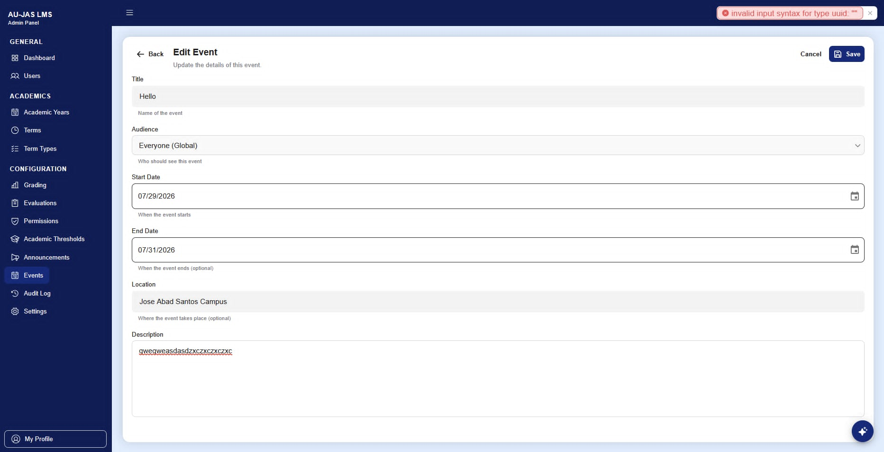

Errors: | Admin panel, can't save/add Events.
Bug Type: | Functional
Module: | Events

- Dashboard (Severinity: S1 Critical)
a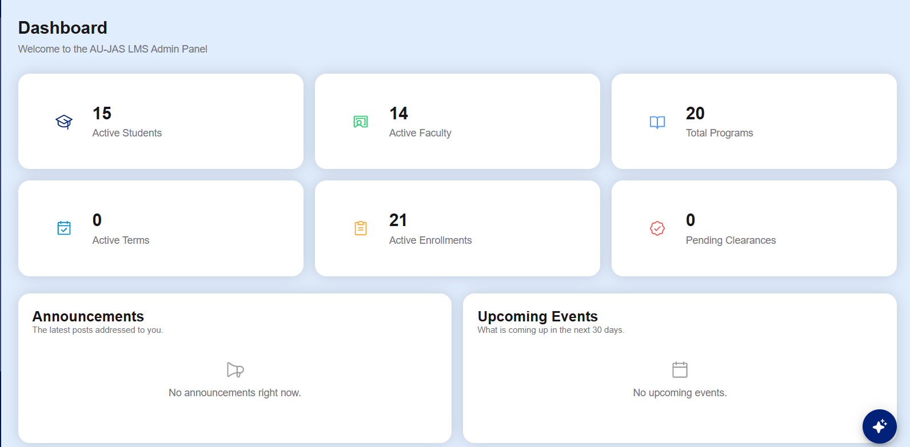

Errors: | Total programs, active terms, pending clearance is not working whenever i clicked them.
Bug Type: | Functional
Module: | Dashboard

- Users (Severinity: S1 Critical)
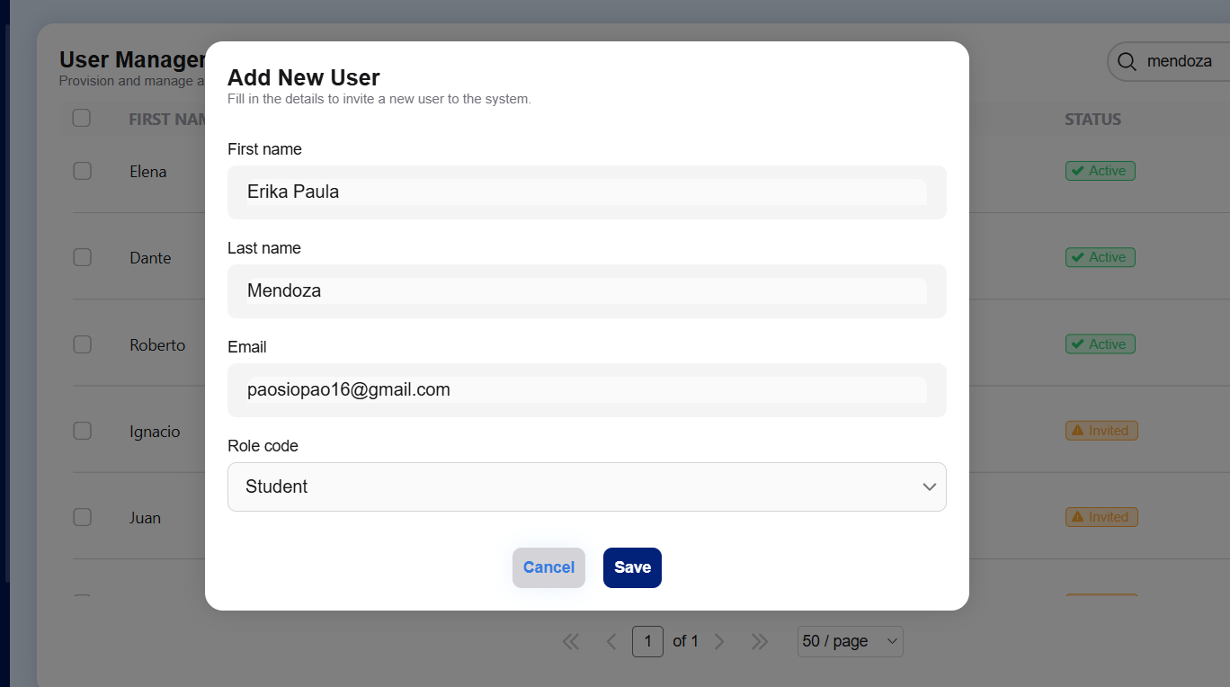

Errors: | Cannot add new user in any role code.
Bug Type: | Functional
Module: | User.

- Ai chatbox (Severity: s3 Medium)
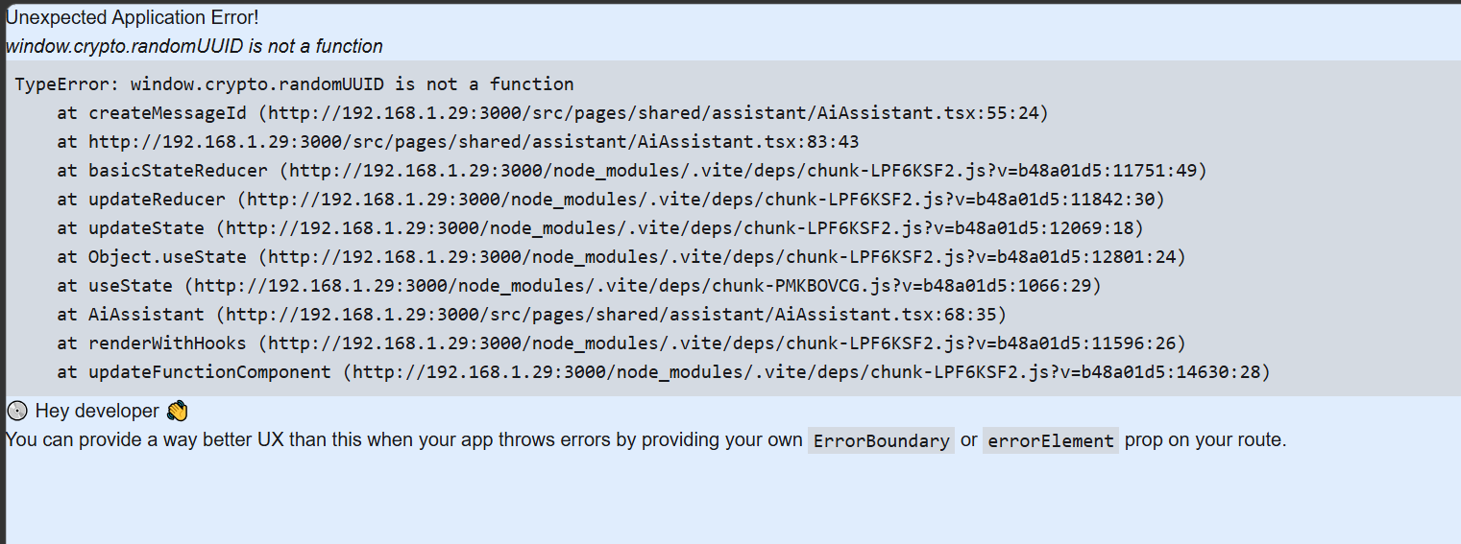

Errors: | Cannot use ai chatbox.
Bug Type: | Crash/Error/Funtional
Module: | chatbox

- User Filter (Severity: s4 Low)
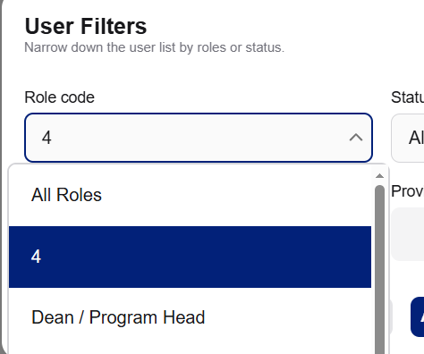

Errors: | Unnecessary is showing.
Bug Type: | copy/text
Module: | User filters

- School Year (Severity: S1 Critical)
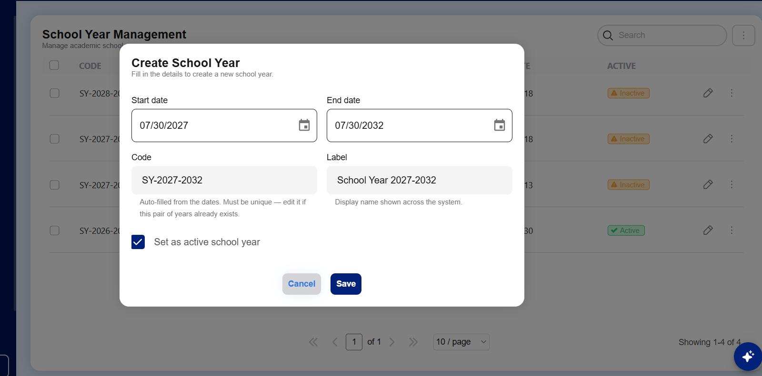

Errors: | Can’t create a school year.
Bug Type: | Functional
Module: | Academic Years

- Announcement (Severity: S2 High)
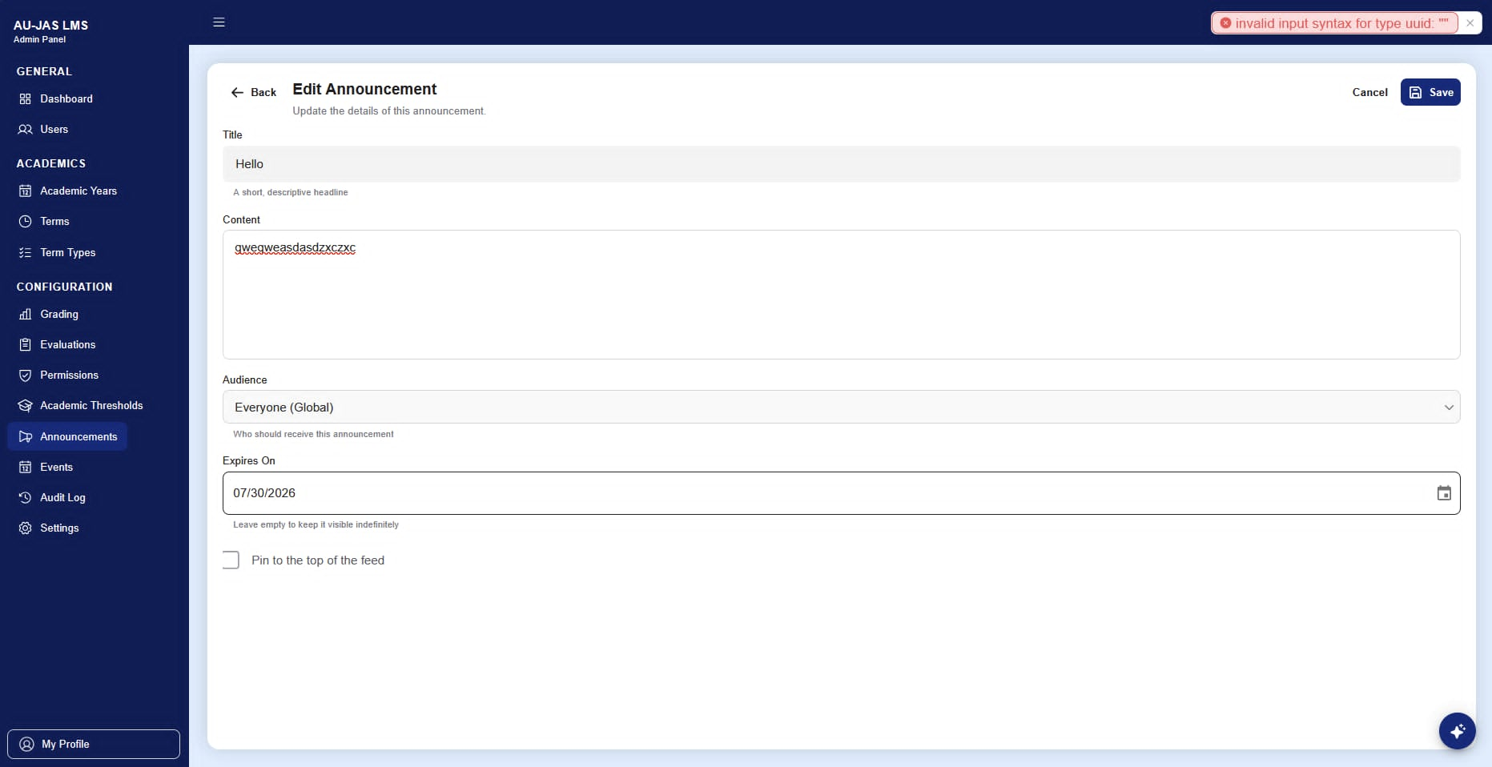

Errors: | can't save/add announcements.
Bug Type: | Functional
Module: | Announcement

- Terms (Severity: S1 Critical)
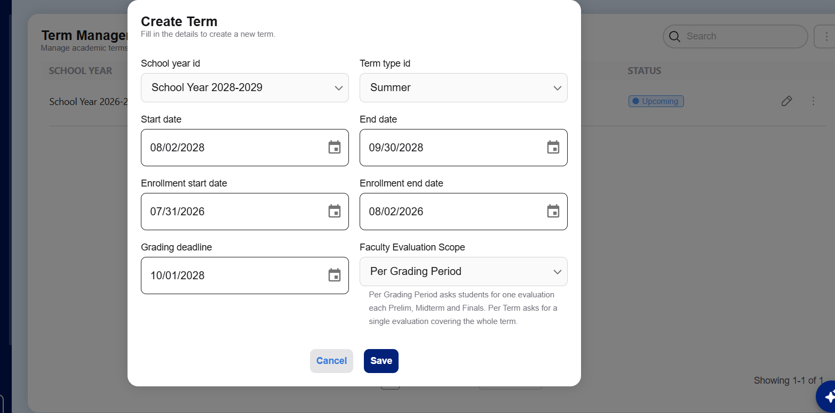

Errors: | can't save/add terms.
Bug Type: | Functional
Module: | Terms

- Term Type (Severity: S2 High)
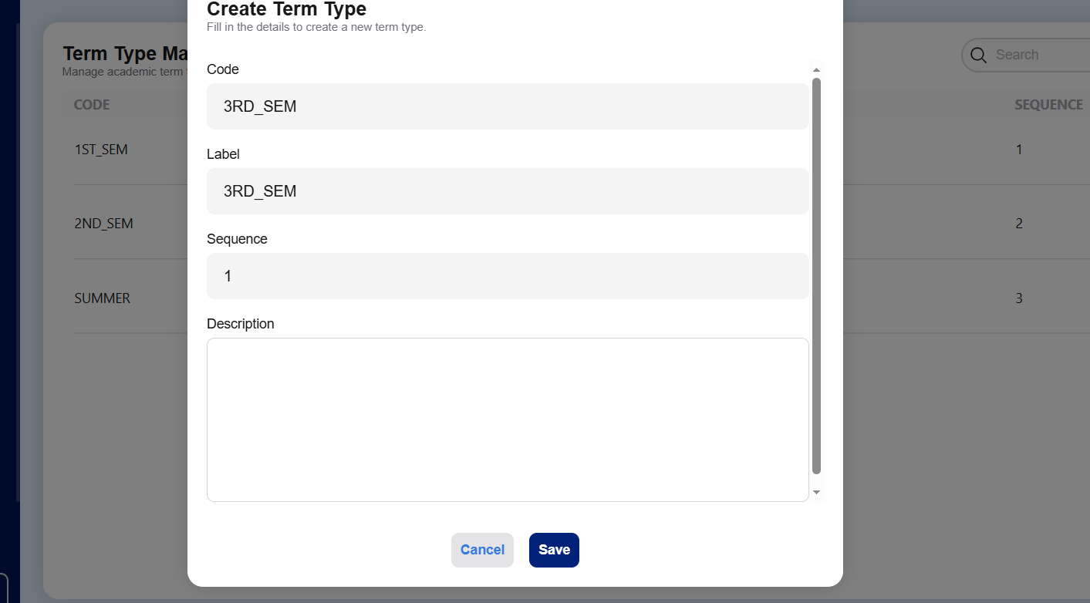

Errors: | can't save/add term type.
Bug Type: | Functional
Module: | Terms

- Grade (Severity: S1 Critical)
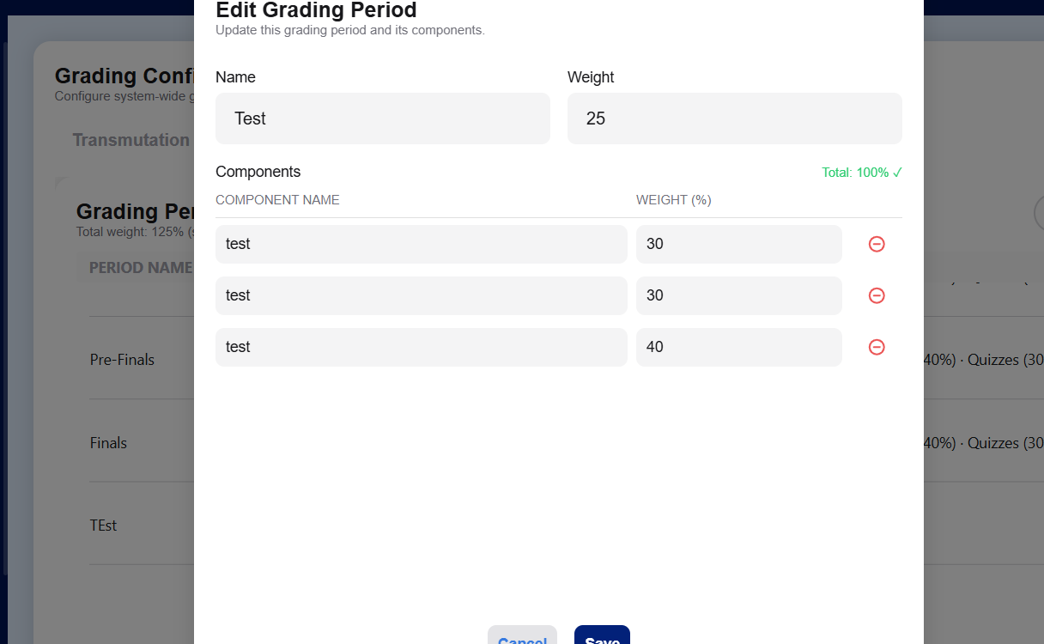
Errors: | can't save/add/edit term grading.
Bug Type: | Functional
Module: | Grade

- Evaluation
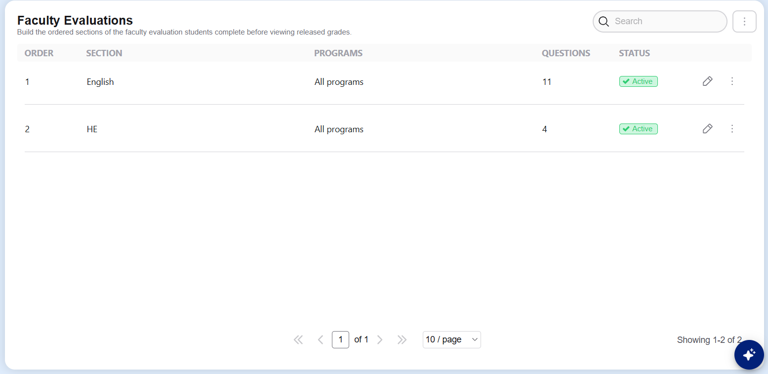

Errors: | can't save/add term evaluation.
Bug Type: | Functional
Module: | Evaluation

- Permissions
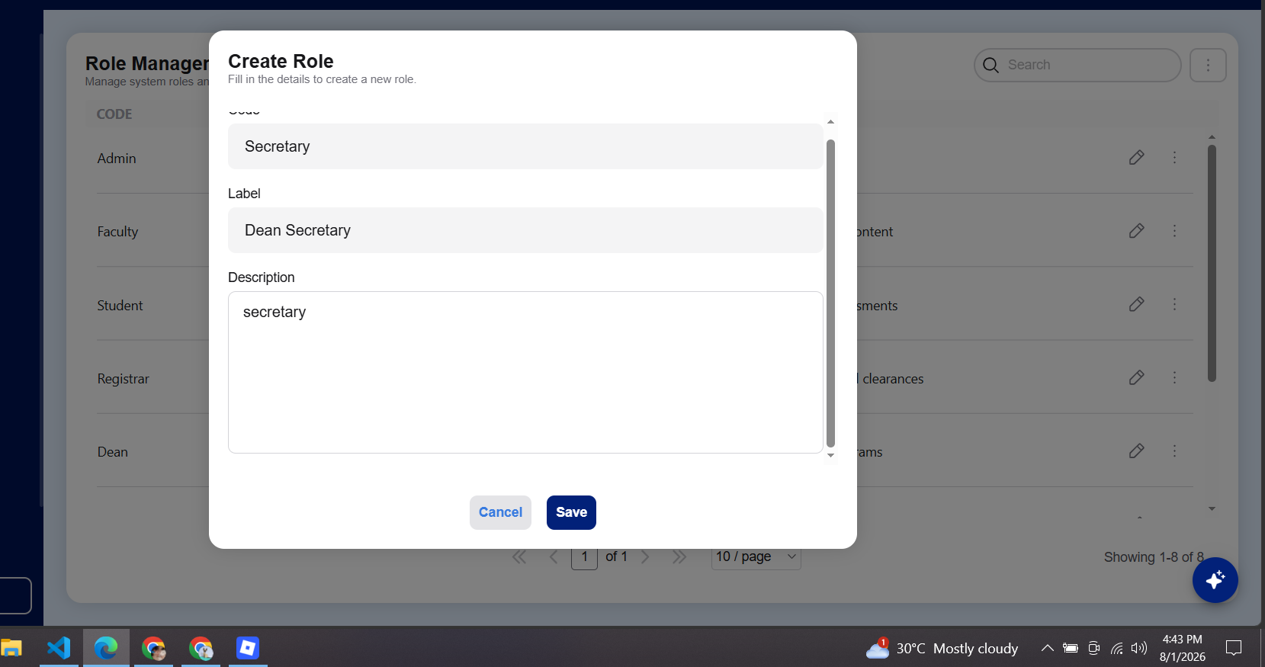

Errors: | can't save/add term role management.
Bug Type: | Functional
Module: | Permissions

User Role: Registrar - hbaki386@gmail.com

- Student (Severity: S5 Low)
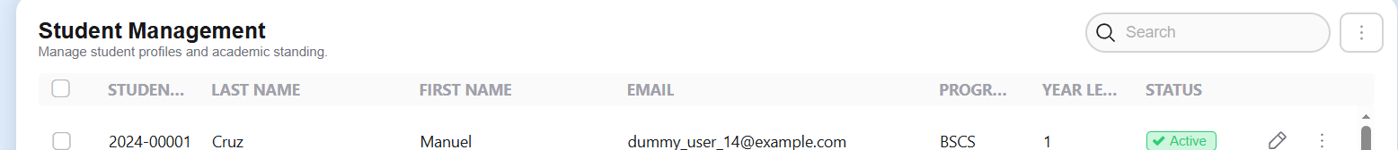

Errors: | The word student can’t read.
Bug Type: | Functional
Module: | Student management
- Registrar chatbox (Severity: S1 Critical)
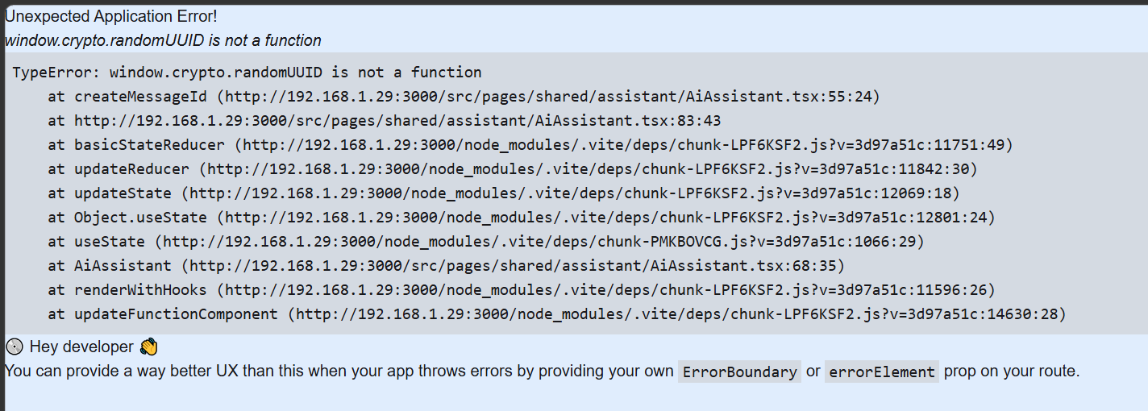

Errors: | I can't use the chatbox and it keeps showing like this.
Bug Type: | Functional/error/crashout
Module: | chatbox

- Enrollment Misplace (Severity: S1 low)
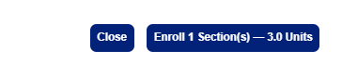

Errors:  Suggestion: | I can’t see the button enrollment and I have to zoom out to see the whole page.  Place it on top of the search bar or somewhere invisible. And make the name- year visible.
Bug Type: | Ui layout
Module: | Manage Student Enrollment

- Enrollment Term (Severity: S2 High)
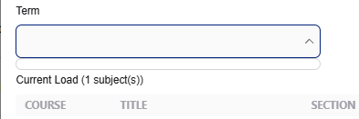

Errors: | Cannot use the term.
Bug Type: | Functional
Module: | Term

- Enrollment
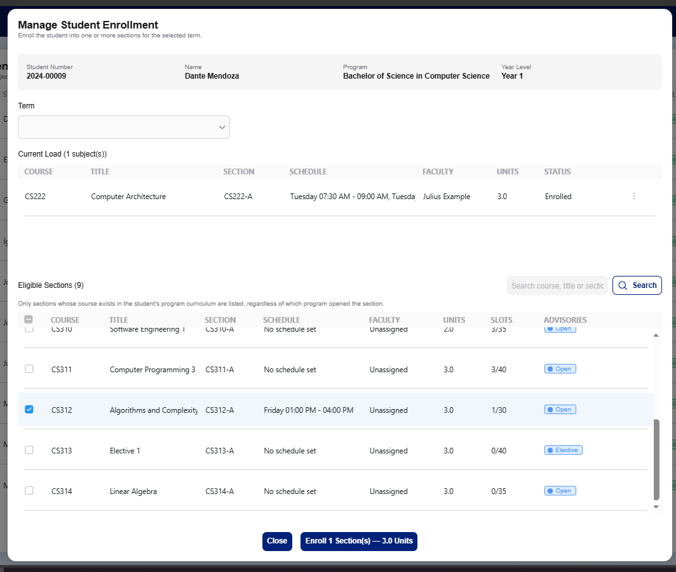

Errors: | Cannot enroll in the subject.
Bug Type: | Functional
Module: | Management Student Enrollment
- Batch Regression (Severity: S1 Critical)
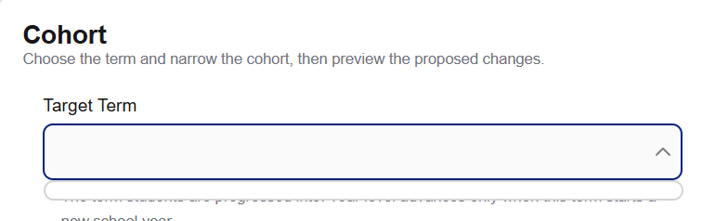
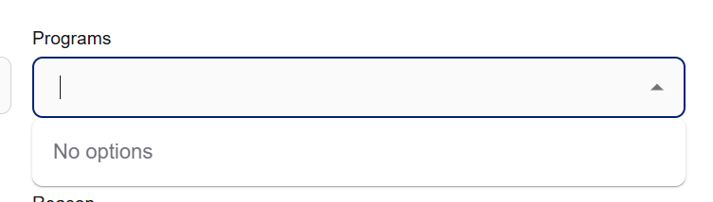

Errors: | Cannot use cohort.
Bug Type: | Functional
Module: | Batch Regression

- Grade Release (Severity: S3 Meduim)
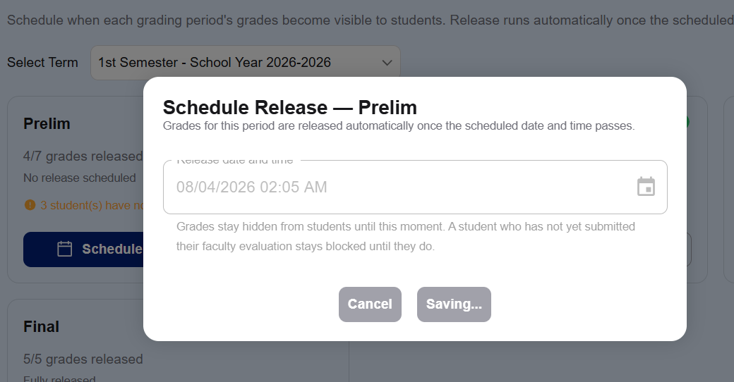

Errors: | Cannot use click anywhere to go back to the page.
Bug Type: | Functional
Module: | Batch Regression

- Announcement (Severity: S1 Critical)
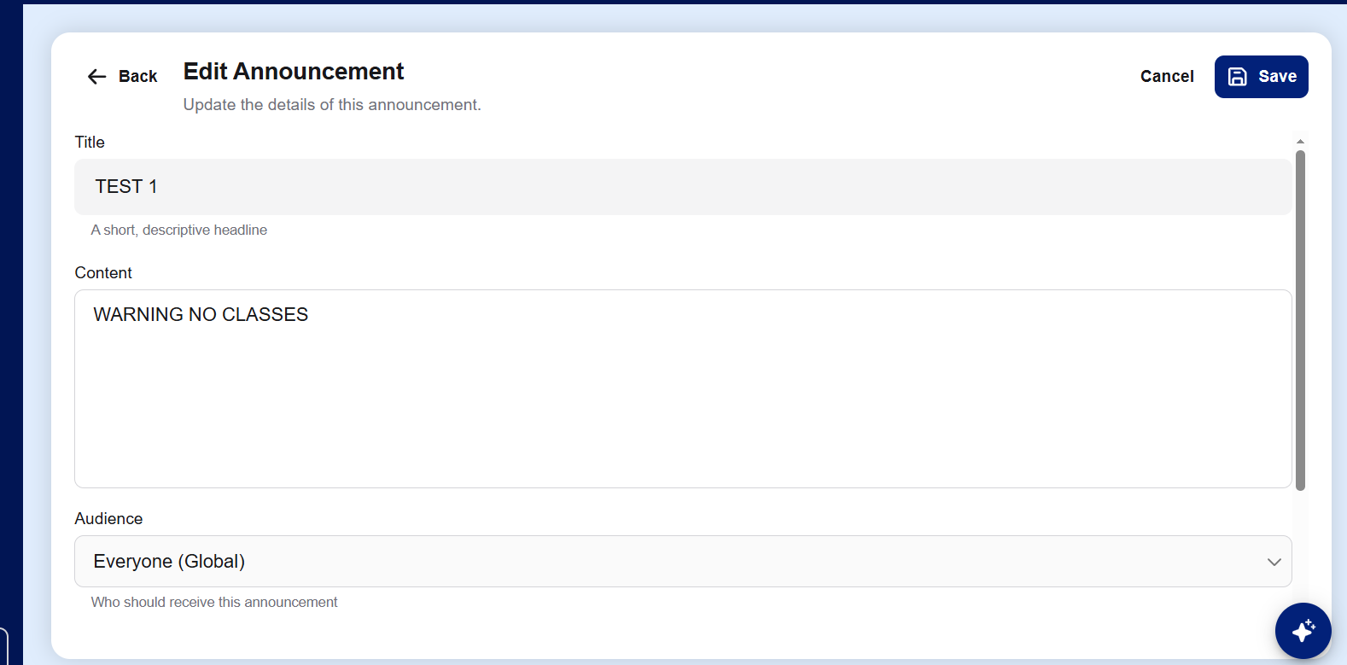

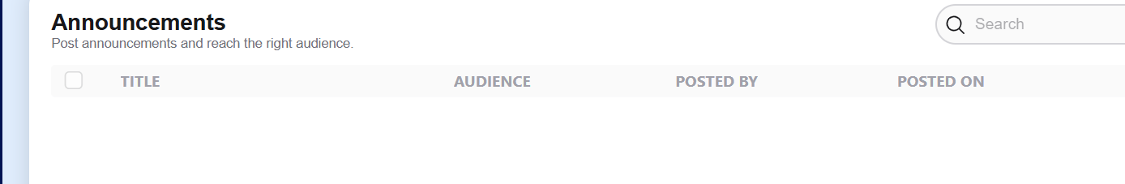

Errors: | Cannot post an announcement.  There’s no text posted by too in the edi announcement page.
Bug Type: | Functional
Module: | Announcement edit

- Events (Severity: S1 Critical)
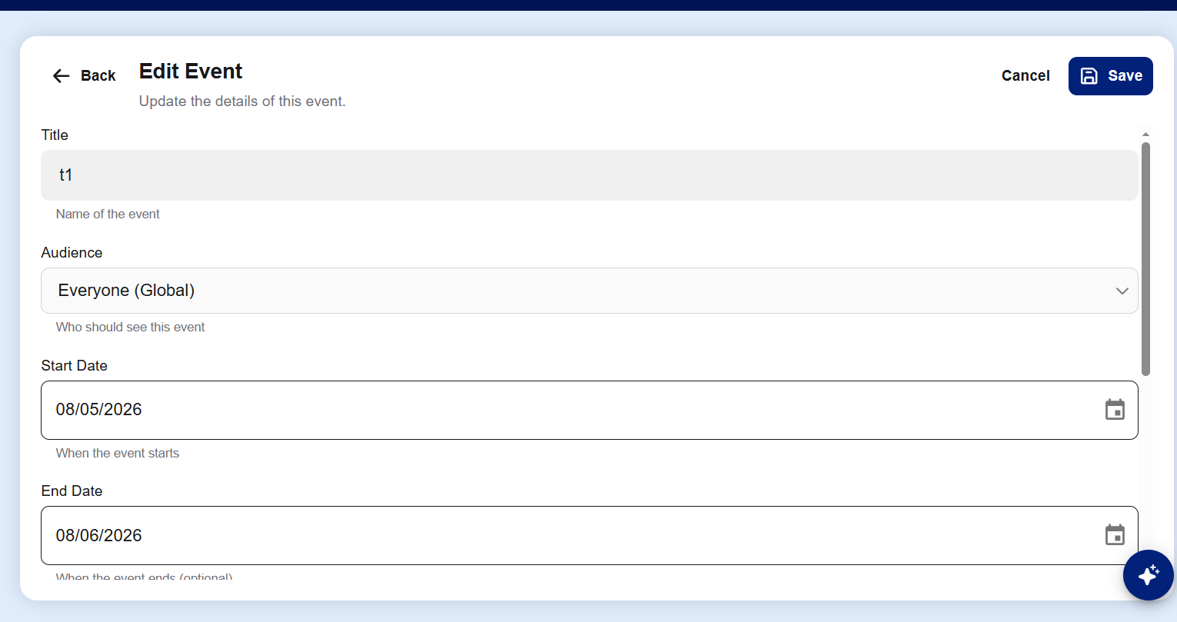
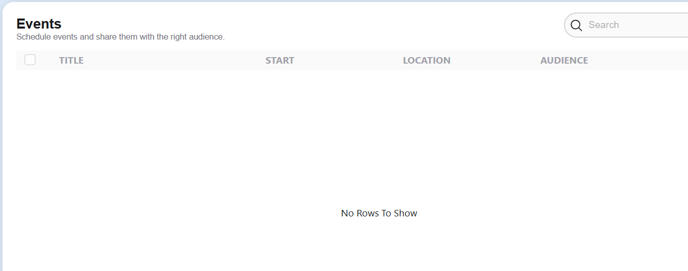
Errors: | Cannot use events.
Bug Type: | Functional
Module: | Edit Events

User Role: Dean - juliustolentino0101@gmail.com

- Dashboard (Severity: S2 Hiigh)
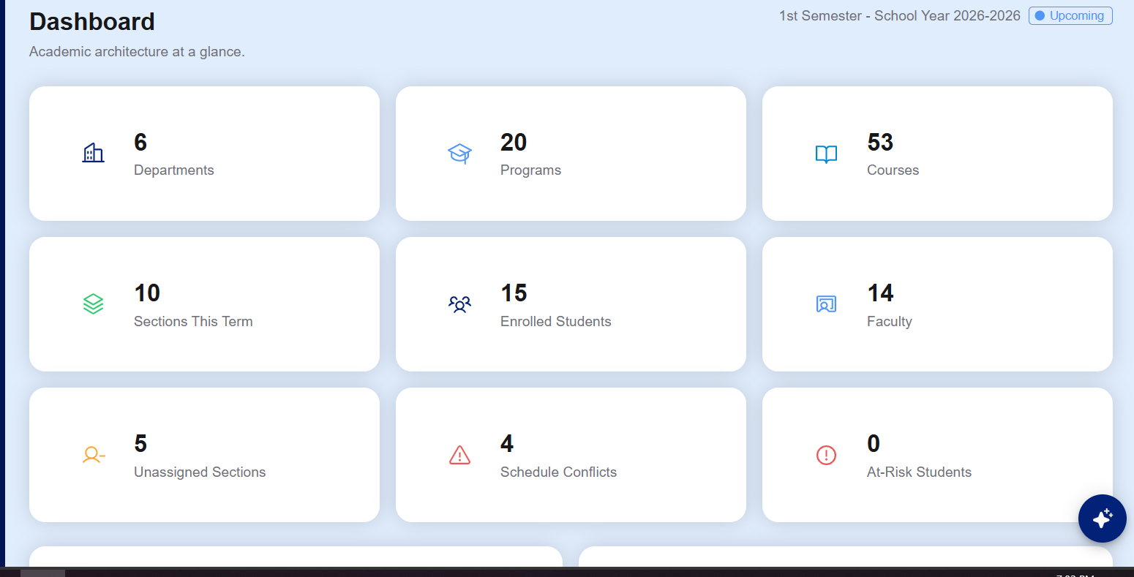

Errors: | “Enrolled students” and “at-Risk Students” are not working
Bug Type: | Functional
Module: | Dean dashboard
- Program Level (Severity: S1 Critical)
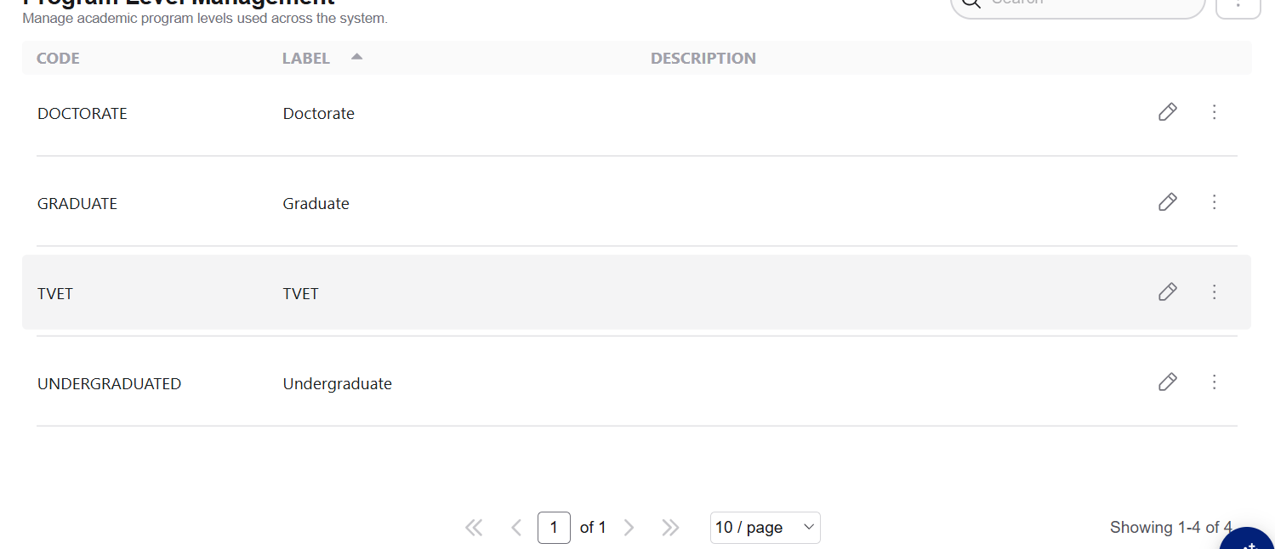

Errors: | Doesn’t work.
Bug Type: | Functional
Module: | Program Level

- Dean Chatbox (Severity: S1 Critical)

Errors: | I can't use the chatbox and it keeps showing like this.
Bug Type: | Functional/error/crashout
Module: | chatbox

- Course Type (Severity: S1 Critical)
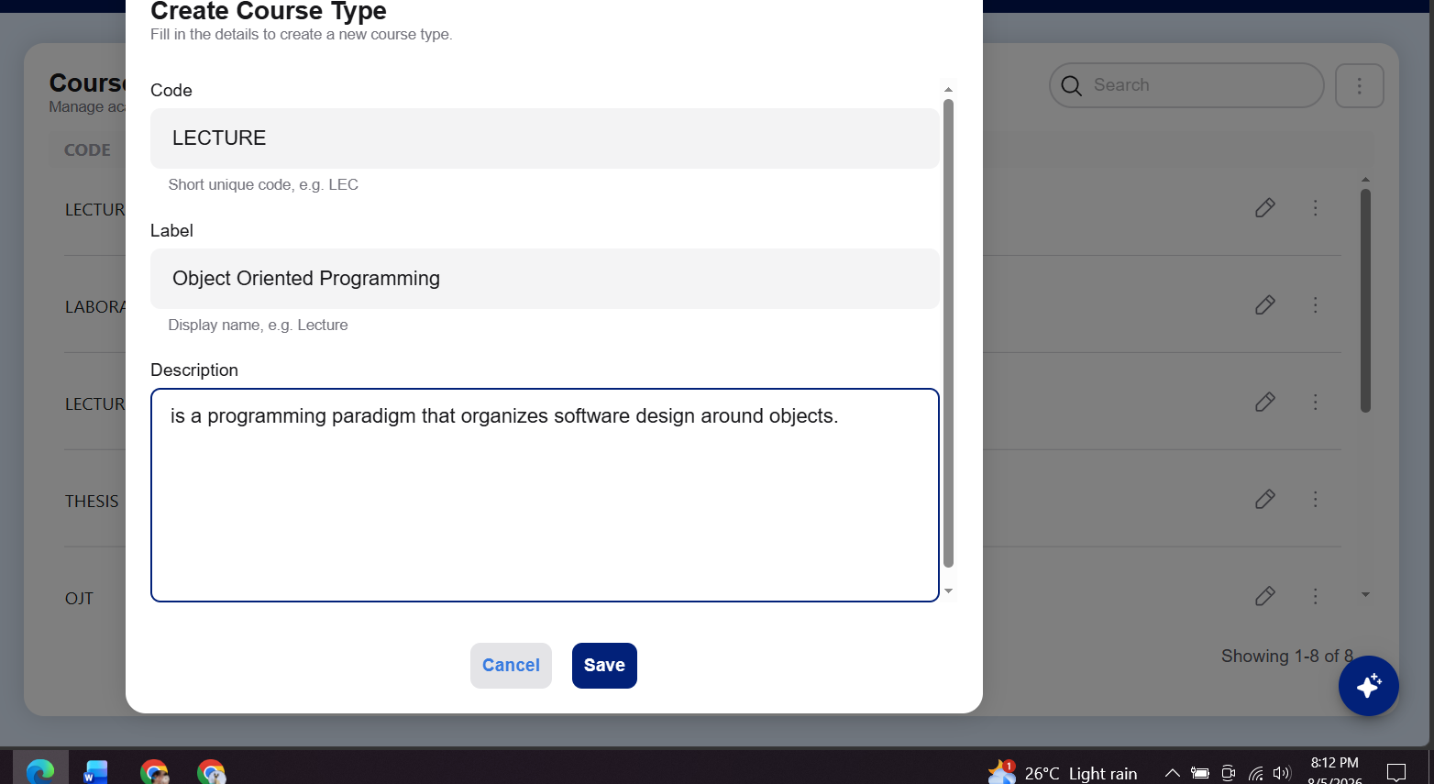
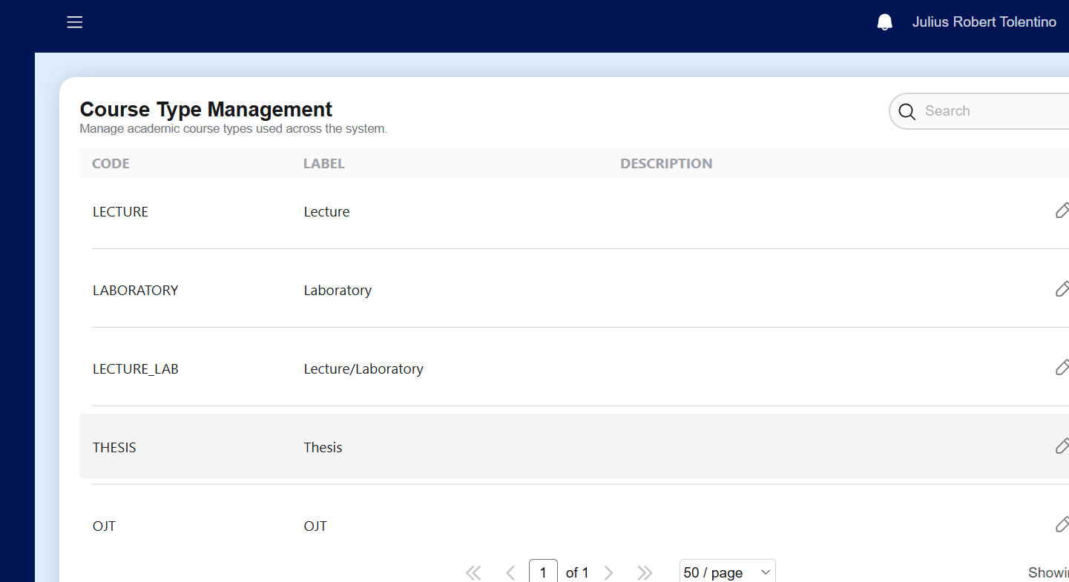

Errors: | I can't create another course.
Bug Type: | Functional/error/crashout
Module: | Course Type Management
- Department (Severity: S2 High)
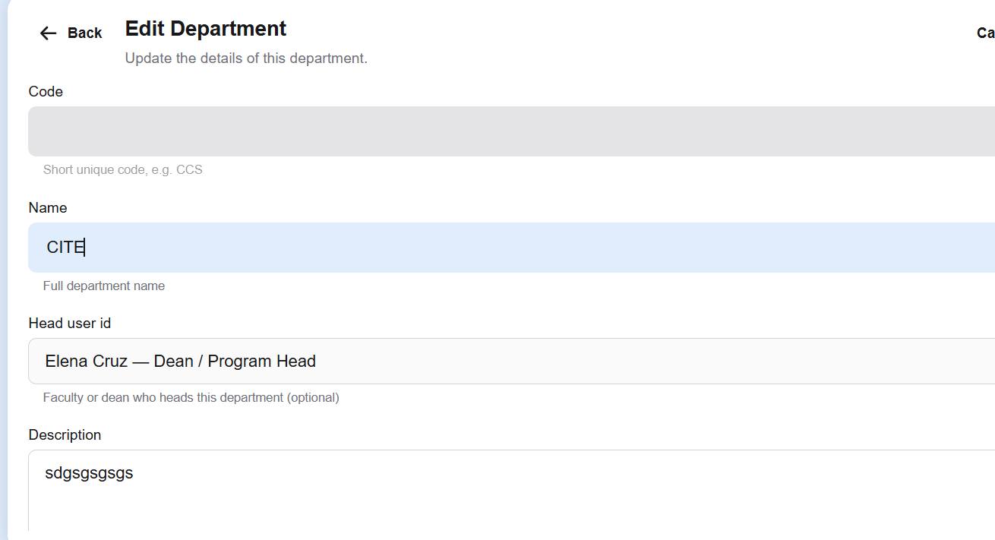

Errors: | I can't create a Department and the code can’t be used.
Bug Type: | Functional
Module: | Edit Department
- Program (Severity: S1 Critical)

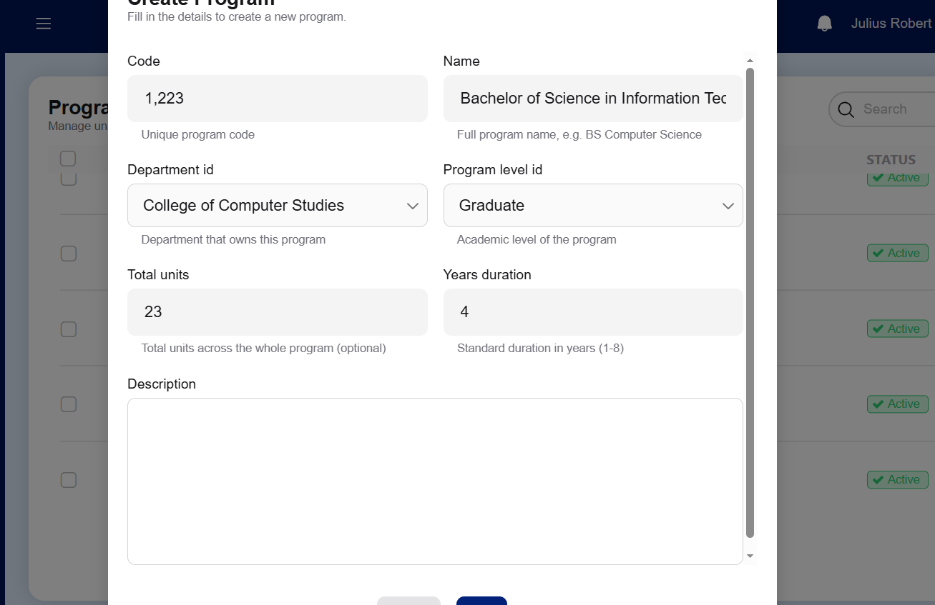

Errors: | I can't type code and it doesn't show what I created.
Bug Type: | Functional
Module: | Create program
- Course (Severity: S4 Low)
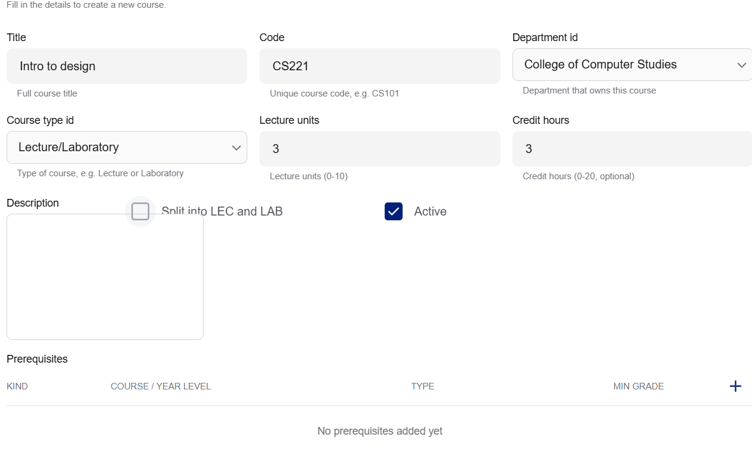

Errors: | There’s a box that is seen and i can’t exit creation, unless i have to refresh the page.
Bug Type: | UI
Module: | Course creation
- Curriculum Map (Severity: S2 High)
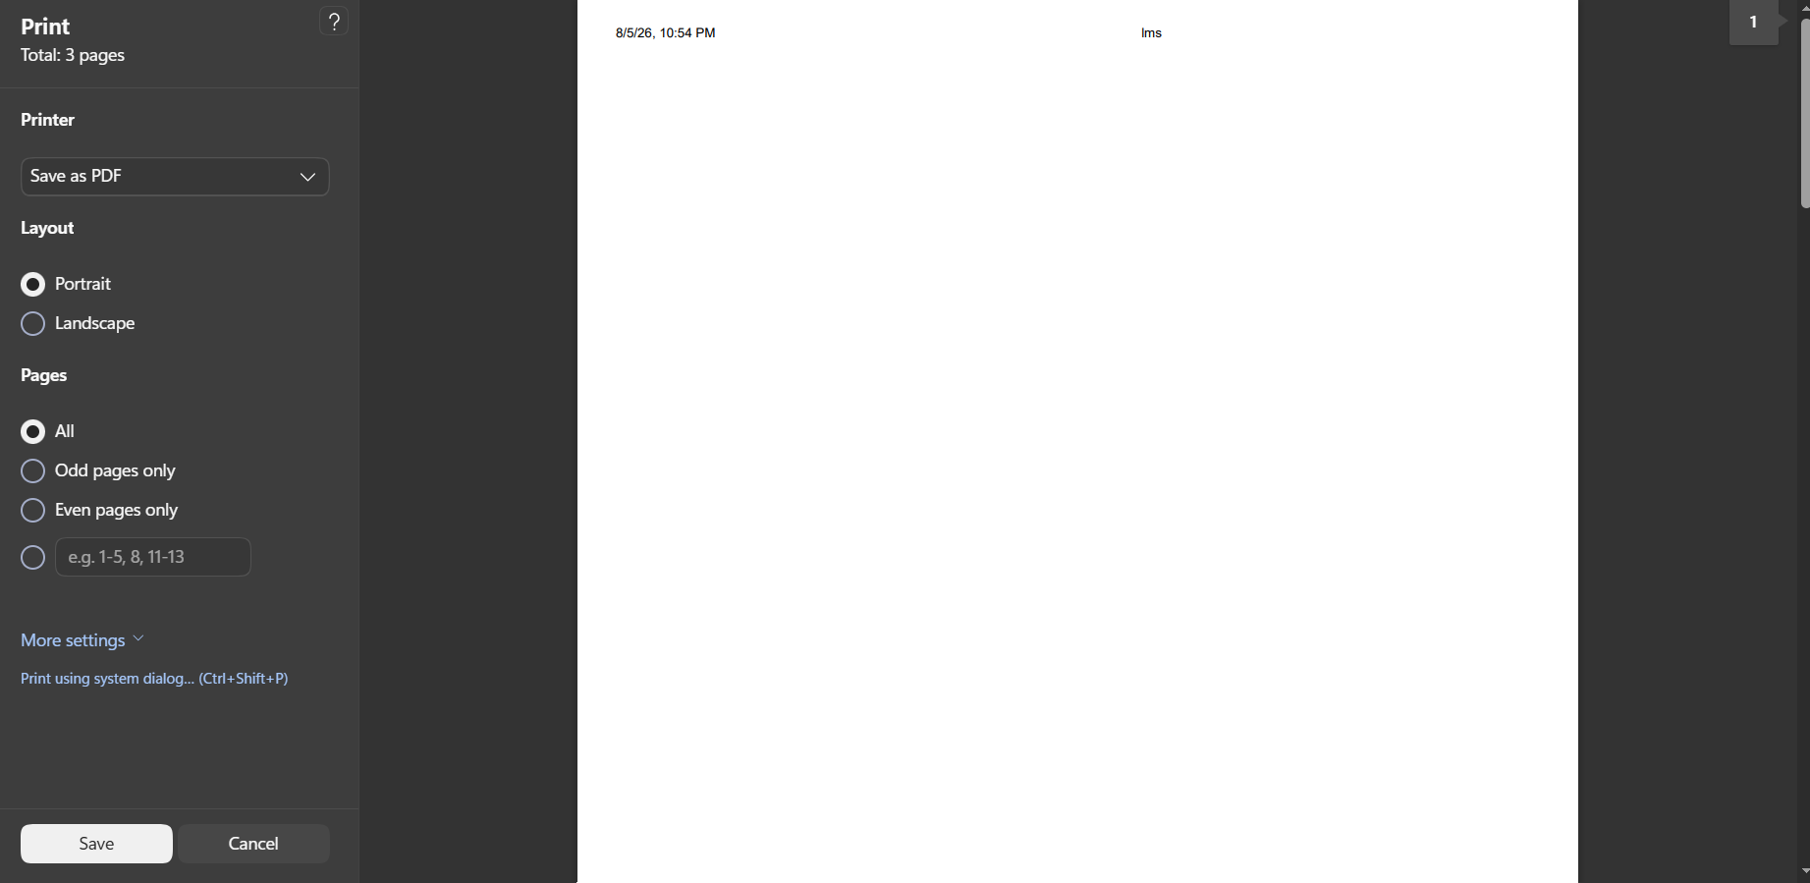

Errors: | I tried to print it out and it showed like this.
Bug Type: | Functional
Module: | Edit Department
- Section (Severity: S1 Critical)
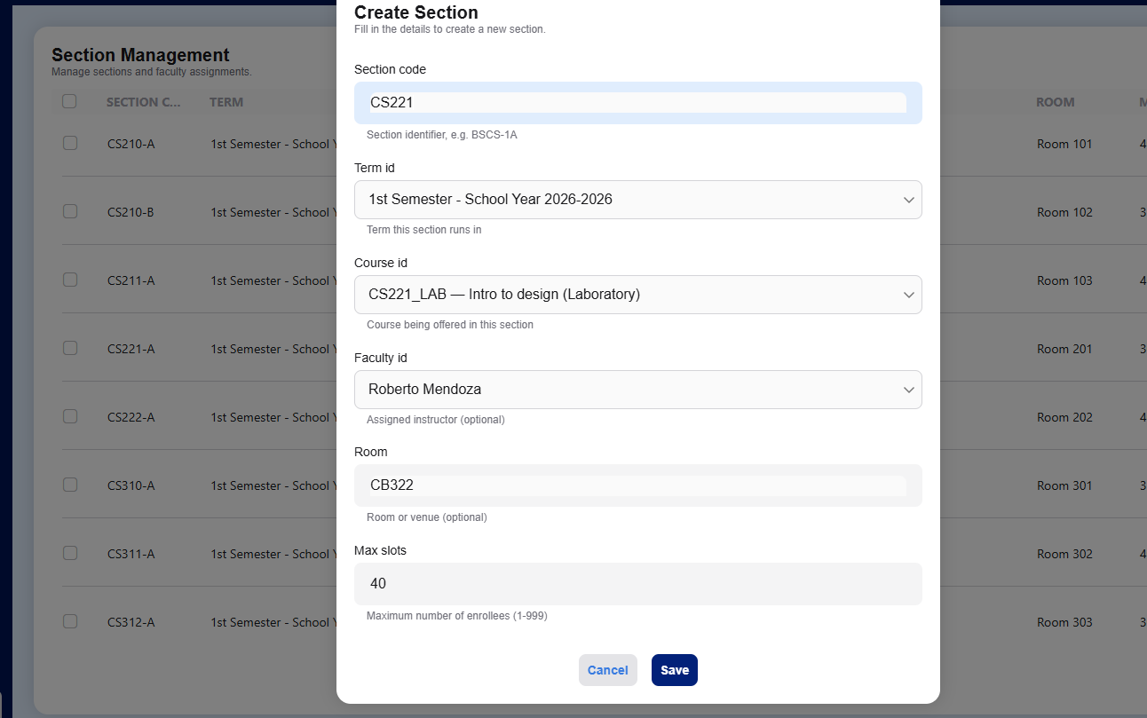

Errors: | Cannot add or save.
Bug Type: | Functional
Module: | Section

User Role: Faculty - juliusexample@gmail.com

- Chatbox (Severity: S1 Critical)

- Program (Severity: S2 High)
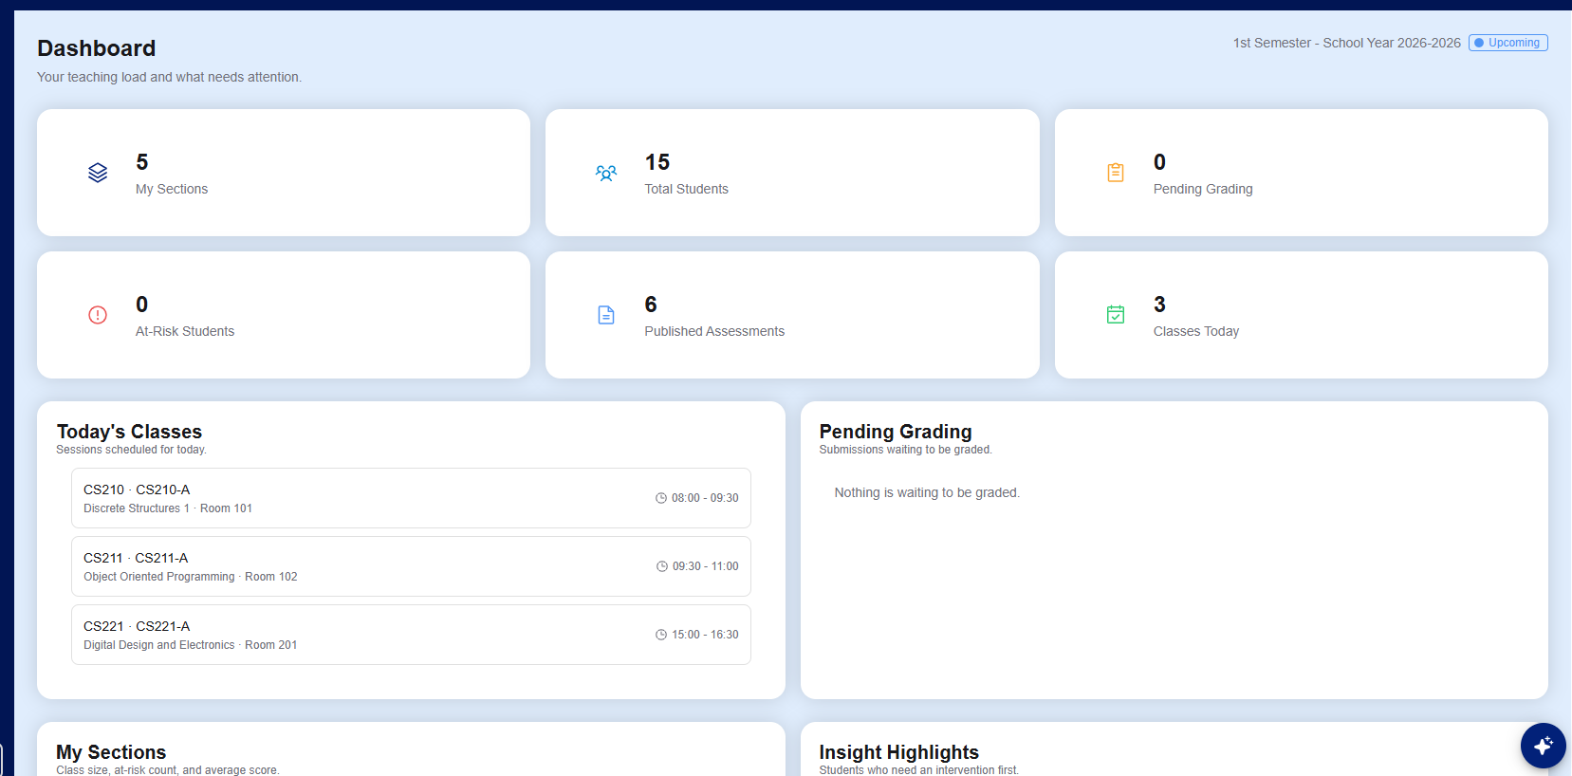

Errors: | “At risk students” didn’t function.
Bug Type: | Functional
Module: | Faculty dashboard

- Announcement
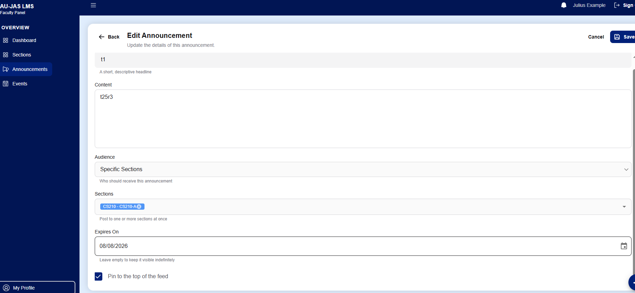
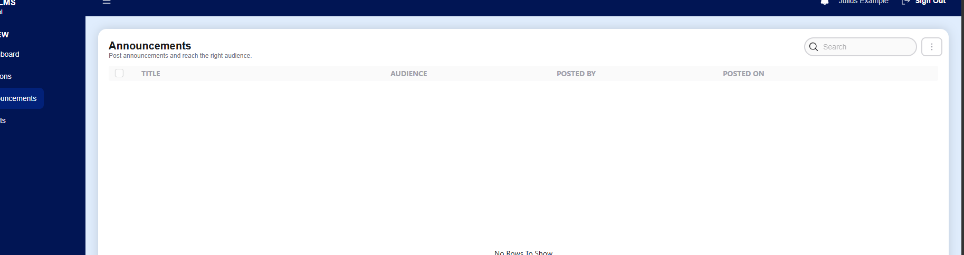

Errors: | I tried to print it out and it showed like this.
Bug Type: | Functional
Module: | Announcement
- Program (Severity: S2 High)
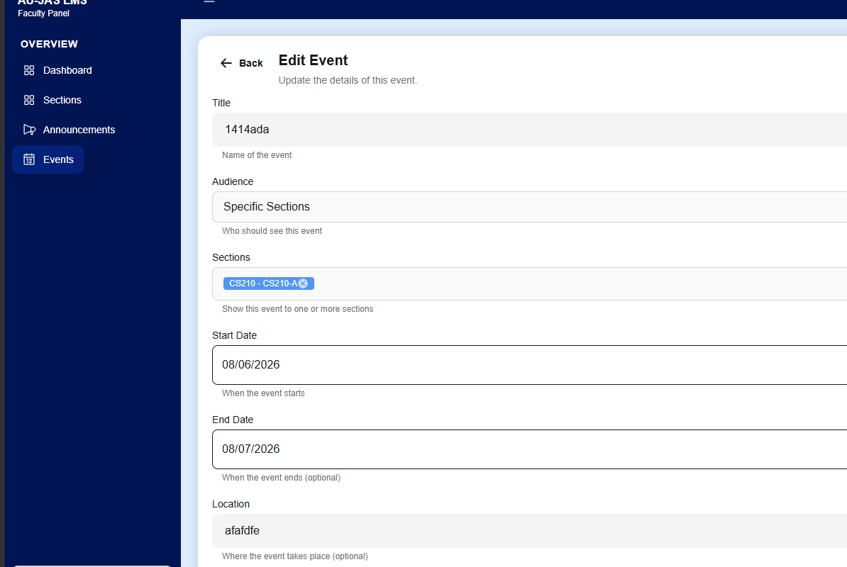

Errors: | I tried to print it out and it showed like this.
Bug Type: | Functional
Module: | Announcement
- Profile (Severity: S3 Medium)
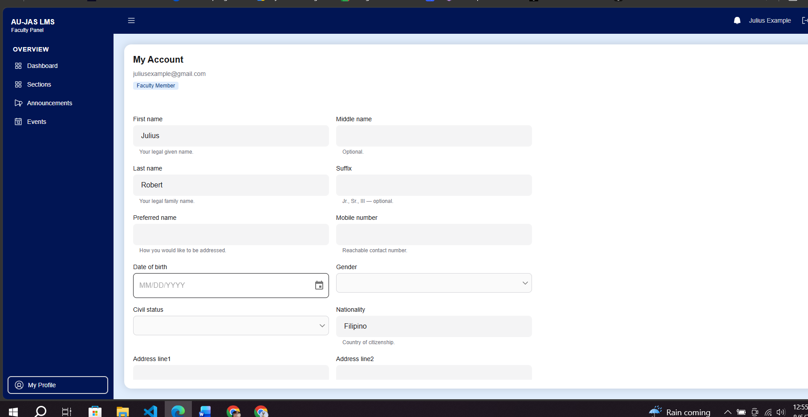

Errors: | It didn’t automatically change, unless it refresh the page.
Bug Type: | Performance
Module: | Announcement

User Role: Student - crowsnight379@gmail.com

- Schedule (Severity: S4 Low)
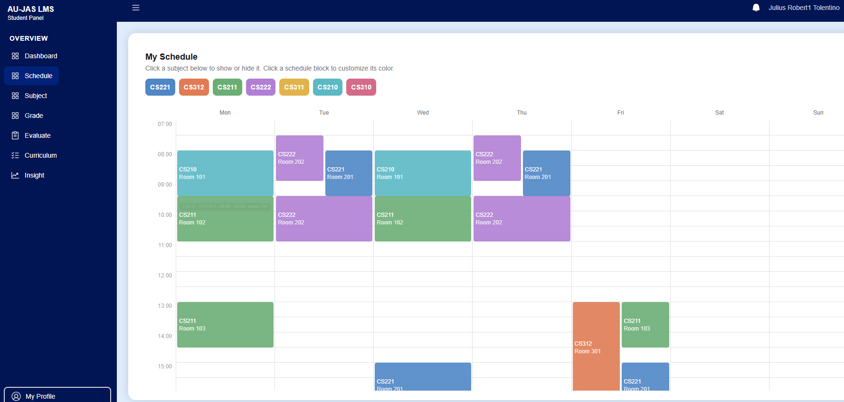

Errors: | Color doesn’t change.
Bug Type: | UI
Module: | My Schedule

- Evaluation

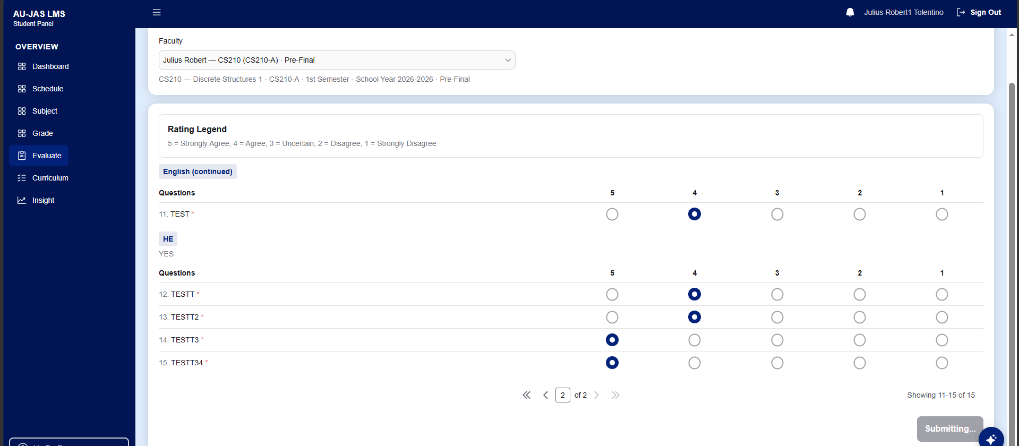
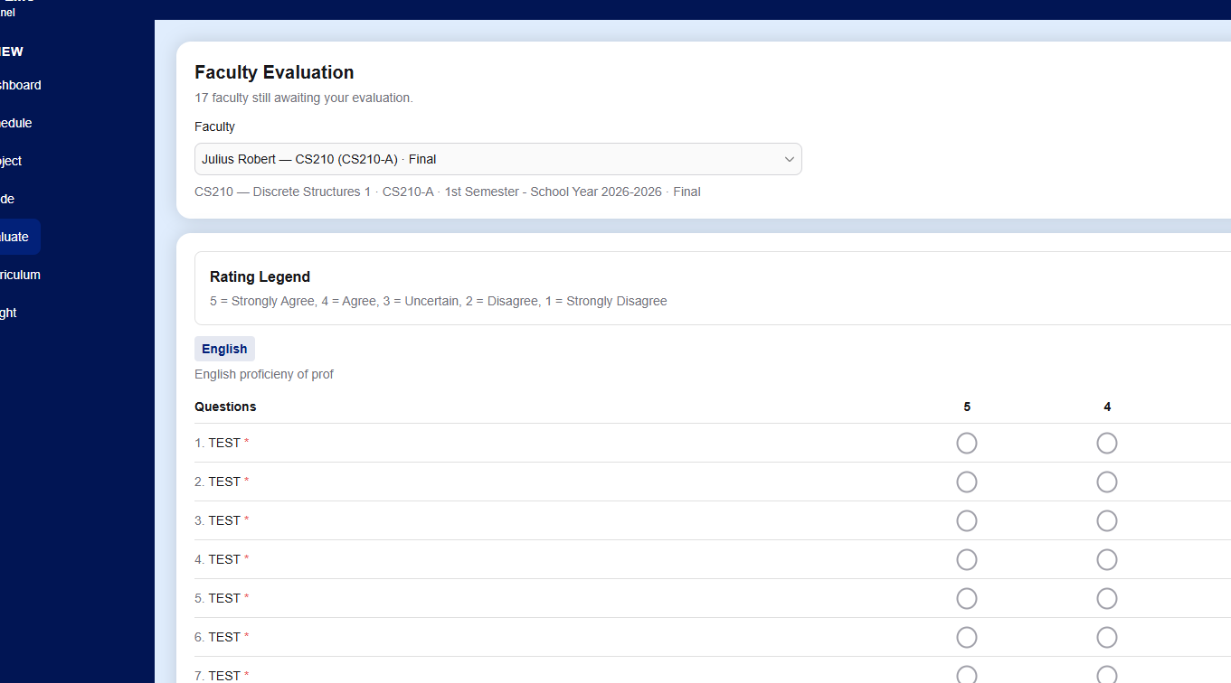

Errors: | It didn’t save my answers.
Bug Type: | Functional
Module: | Assesmentz

- Grade (Severity: S2 High)
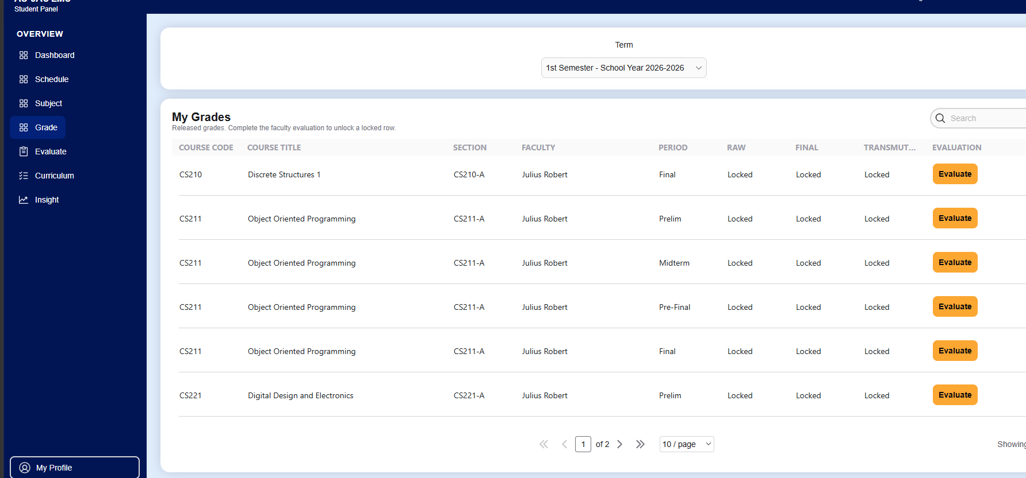

Errors: | I answered it and its still locked
Bug Type: | Functional
Module: | My Grade

- Student chatbox (Severity: S1 Critical)

Errors: | I can't use the chatbox and it keeps showing like this.
Bug Type: | Functional/error/crashout
Module: | chatbox

